**COMPILER LAB REPORT**

**NAME** – ANKUR MANNA

**CLASS** – BCSE III

**ROLL NO** : 18

**SECTION** – A1

**ASSIGNMENT NUMBER 1**

**DEADLINE**: 27TH March, 2021

**SUBMITTED ON**: 27TH March, 2021

**REPORT SUBMITTED ON**: 27THMarch, 2021

**1.Write a lex file to count the number of lines, words, and characters in the input.**

%{

#include<stdio.h>

#include<string.h>

int i = 0;

int ch=0;

int ln=0;

%}

/* Rules Section*/

%%

([a-zA-Z0-9])* {i++;} /* Rule for counting number of words*/

. {ch++;}

"\n" {ln++; }

%%

int yywrap(void){}

int main(int argc ,char* argv[])

{

    if(argc > 1)

    {

        FILE *fp = fopen(argv[1], "r");

        if(fp)

            yyin = fp;

    }

    yylex();

    printf("%d %d %d",i,ch,ln);

    return 0;

}

**OUTPUT:**

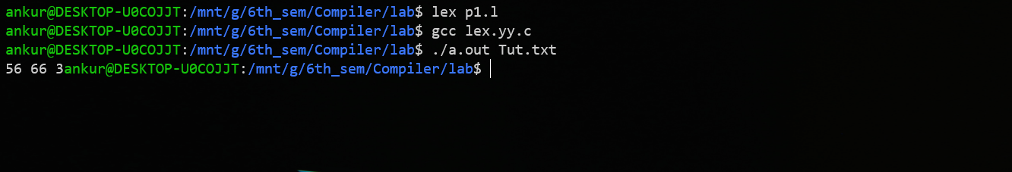

**Input File Tut.txt**

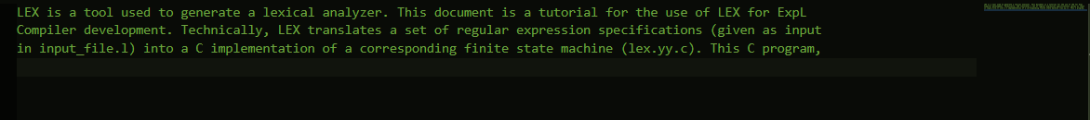

**2. Write a lex file to count the number of numbers appearing in the input. Count the number of integers (without a decimal) separately from the number of floating point numbers (with a decimal, and at least one digit on either side of the decimal).**

%{

#include<stdio.h>

    /* Definition section */

    int integer=0;

    int fractions=0;

%}

/* Rule Section */

DIGIT [0-9]

%%

\-?{DIGIT}+          {integer++;}

\-?{DIGIT}*\.{DIGIT}+ {fractions++;}

"\n"    {

            printf("\nNo. of Integrs: %d", integer);

            integer = 0;

            printf("\nNo. of  fractions: %d", fractions);

            fractions = 0;

     }

%%

// driver code

int main()

{

    yylex();

    return 0;

}

**OUTPUT:**

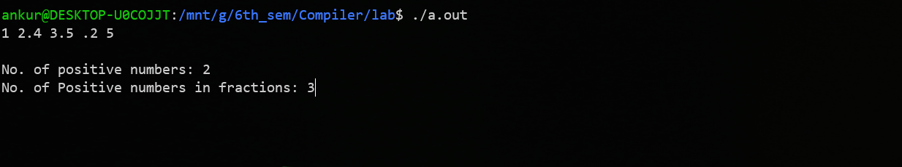

**3.Write a lex file to count the number of words in an input text that start with a vowel.**

%{

    int vow_count=0;

    int const_count =0;

%}

ALPHA [a-zA-Z0-9]

%%

[aeiouAEIOU][A-Za-z]+  {vow_count++;}

[aeiouAEIOU]           {vow_count++;}

[A-Za-z(^aeiouAEIOU)][A-Za-z]+ {const_count++;}

"\n" {printf("%d\n", vow_count);  vow_count = 0;}

%%

int yywrap(){}

int main()

{

    printf("Enter the string of vowels and consonants:");

    yylex();

    return 0;

}

**OUTPUT:**

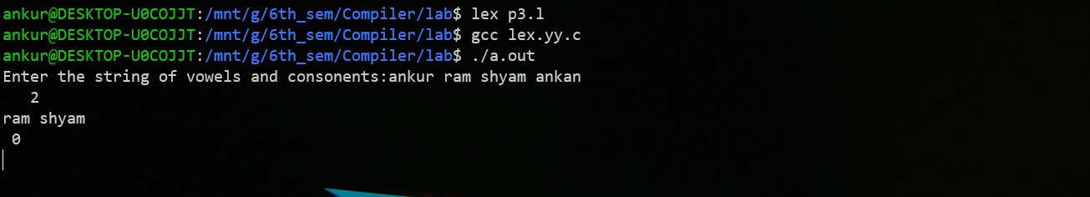

-------------------------------------------------------------------------The End---------------------------------------------------------------------------